Toggle Control Use case:

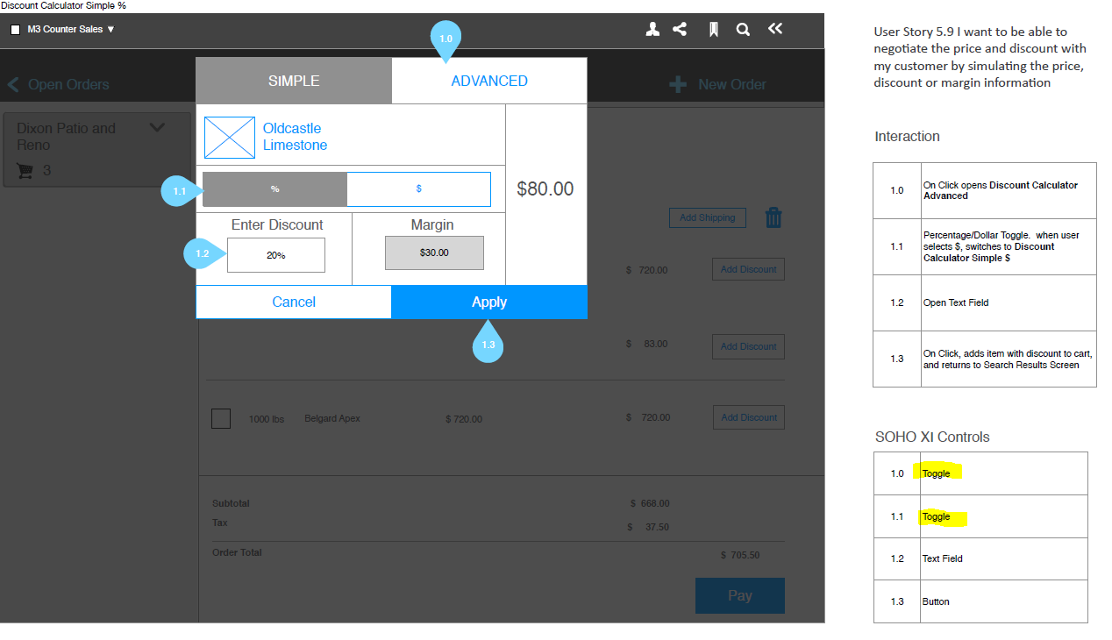

Use Cases:

Two toggle buttons in the modal. SIMPLE and ADVANCED.

When we click on SIMPLE BUTTON, the color should be grey and it should stay until we click on ADVANCED BUTTON. ADVANCED BUTTON color should be white.

When we click on ADVANCED BUTTON, the color should be grey and it should stay until we click on SIMPLE BUTTON. SIMPLE BUTTON color should be white.

We need an Active button when the page initiated. Either SIMPLE or ADVANCE depends on user settings.

Same Toggle control for the % and $ buttons.

